# Software Engineering Selective - project proposal online-pubquiz

WS 2021/2022

|  |  |
| --- | --- |
| **Topic** | *Back to normal* |
| **Project name** | [*www.online-pubquiz.at*](http://www.online-pubquiz.at) |
| **Team members** | *Michael Hörmann*  *Gerhard Lambrecht*  *Paul Kunisch*  *David Hasenhüttl* |
| **GitHub URL** | *https://github.com/hasenhuettl/Pubquiz/* |

# Motivation and Background

*The Covid-19 pandemic led to a prolonged exposure to stress. The fear of the virus, the separation from loved ones and missing social interaction have a big psychological and social impact on the population.[1] The motivation of our project is to bring people back together in a fun and engaging online-activity, no matter if you are in quarantine or meeting each other in person.*

# Approach

*The web application should allow for the popular Pub Quizzes to happen regardless of the current pandemic. Participants will be able to face off against other participants by themselves or in groups. There will be up to 8 different groups in a single private online room. Private Rooms are password protected and created by Quiz Masters. In their respective room, Quiz masters are able to create their own questions. They can choose between multiple/single choice questions, free text questions and picture-aided questions. Once the questions are ready and the participants have joined, the Quiz Master can start the game. After the quiz starts, every group leader is presented with the first question. Group leader can share their screen via external applications like Discord/Skype/… or share their screen in person. After every group leader has submitted their answer, or the time has run out, the answers are delivered back to the quiz master and the new question gets presented to the groups. At the end of the quiz, the results are returned to the participants.*

*The target audience are student groups and colleagues between the age of 18 and 40.*

# General data protection regulation

*Users only need a username and the quiz password to participate in a quiz.*

*Admins and quiz masters can create an account with a username, email address and password.*

# Related projects

*The following projects show similarities to our project:*

* *Kahoot [2]*

*Kahoot is a game-based, interactive, quiz format for educators. It is also played with multiple choice questions set by a quiz master (teacher), but its design is focused on a younger audience and only the top performers are shown at the result page.*

* *Virtualquiz [3]*

*virtualquiz.app is an online Pub quiz application, with a very similar structure and motivation compared to our project. But Virtualquiz does not offer the ability to show questions or create time limits. The answers are free text answers only and are graded manually.*

* [*Ahaslides [4]*](https://ahaslides.com/de/)

*Ahaslides.com is a platform for audience interaction in presentations. It covers a very wide range of features and includes the possibility to use sound files for questions, or to use the application for completely different purposes like polls.*

* *Quizduell [5]*

*The popular Quizduell App is an app to challenge your friends to a series of multiple-choice questions in a selected field of expertise. It offers pre-defined multiple-choice questions and is only played between two people.*

*We want to provide the possibility to create different kinds of question/answer formats. We want to keep it simple and only focus on quizzing.*

# Appendix

## Mock-ups:

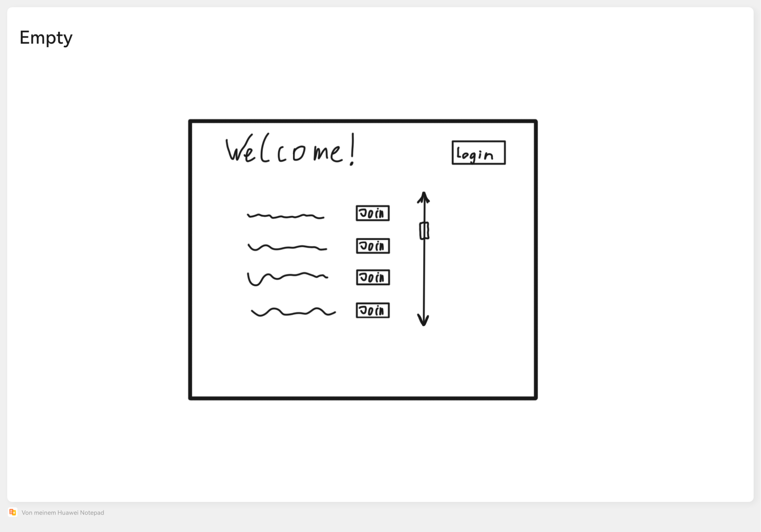

Figure 1: Overview of existing rooms

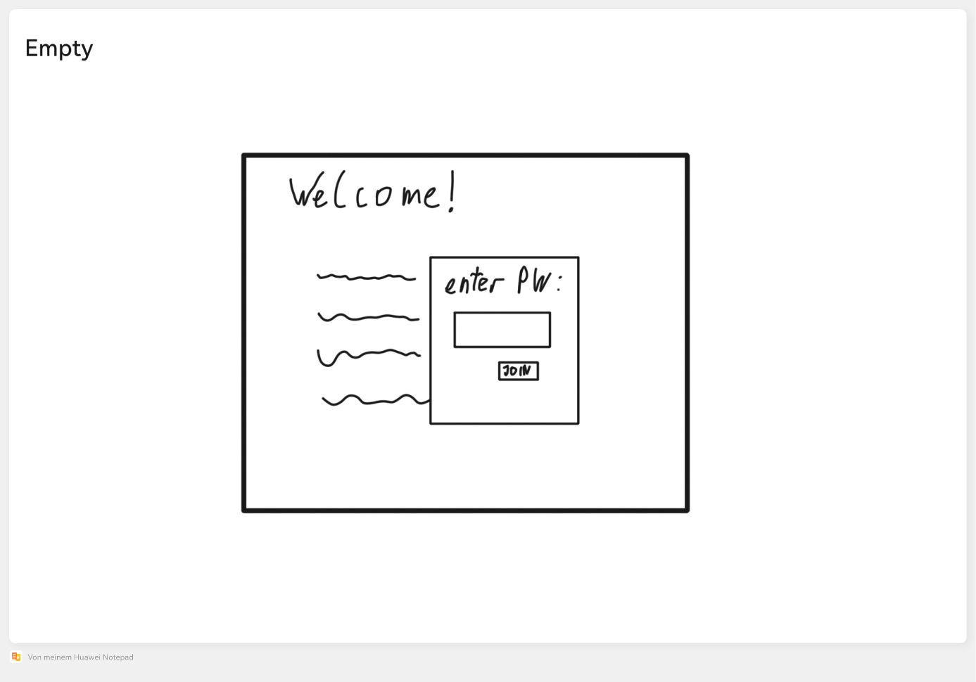

Figure 2: Password prompt for joining a room

*Ein Bild, das Text enthält.
*

Figure 3: Multiple/single-choice question from a players’ POV with timer enabled

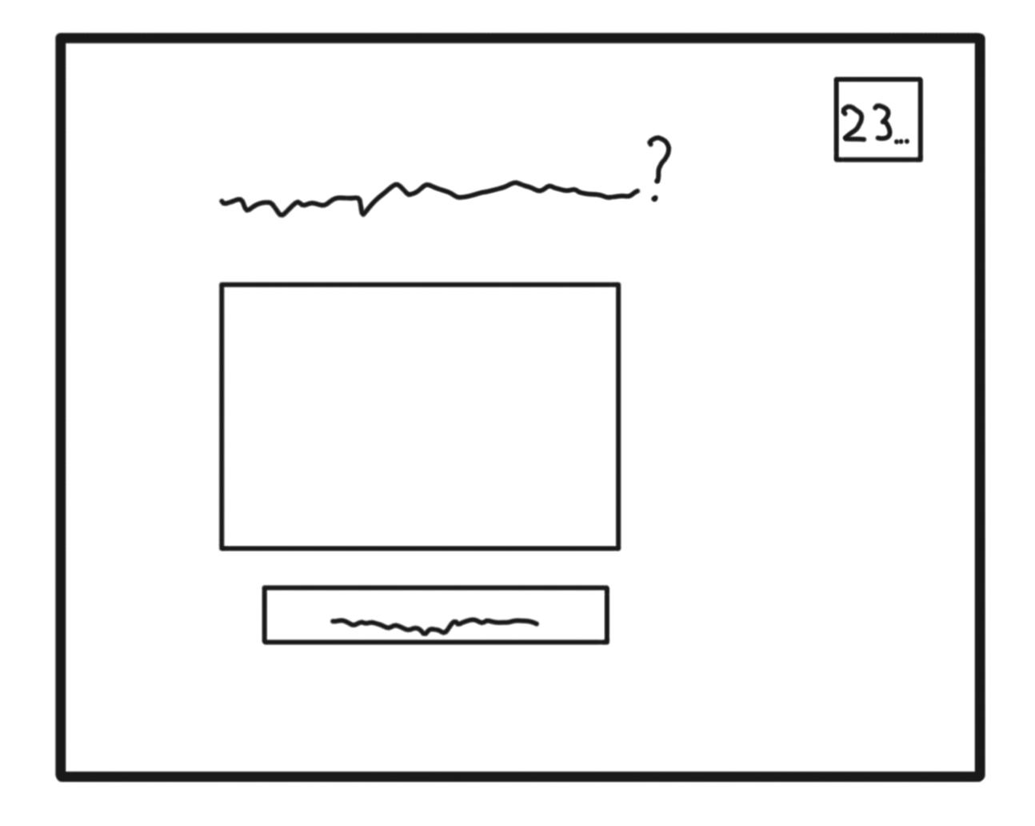

Figure 4: Free text question from a players’ POV with timer enabled

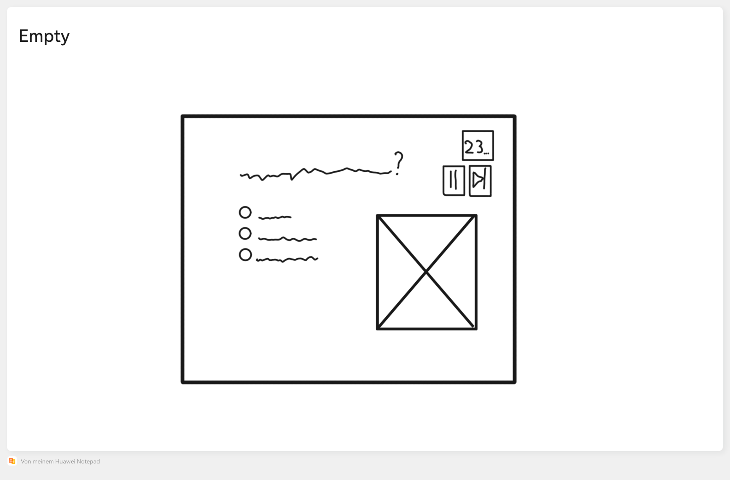

Figure 5: Multiple/single-choice question with picture from the quiz moderator’s POV with timer enabled

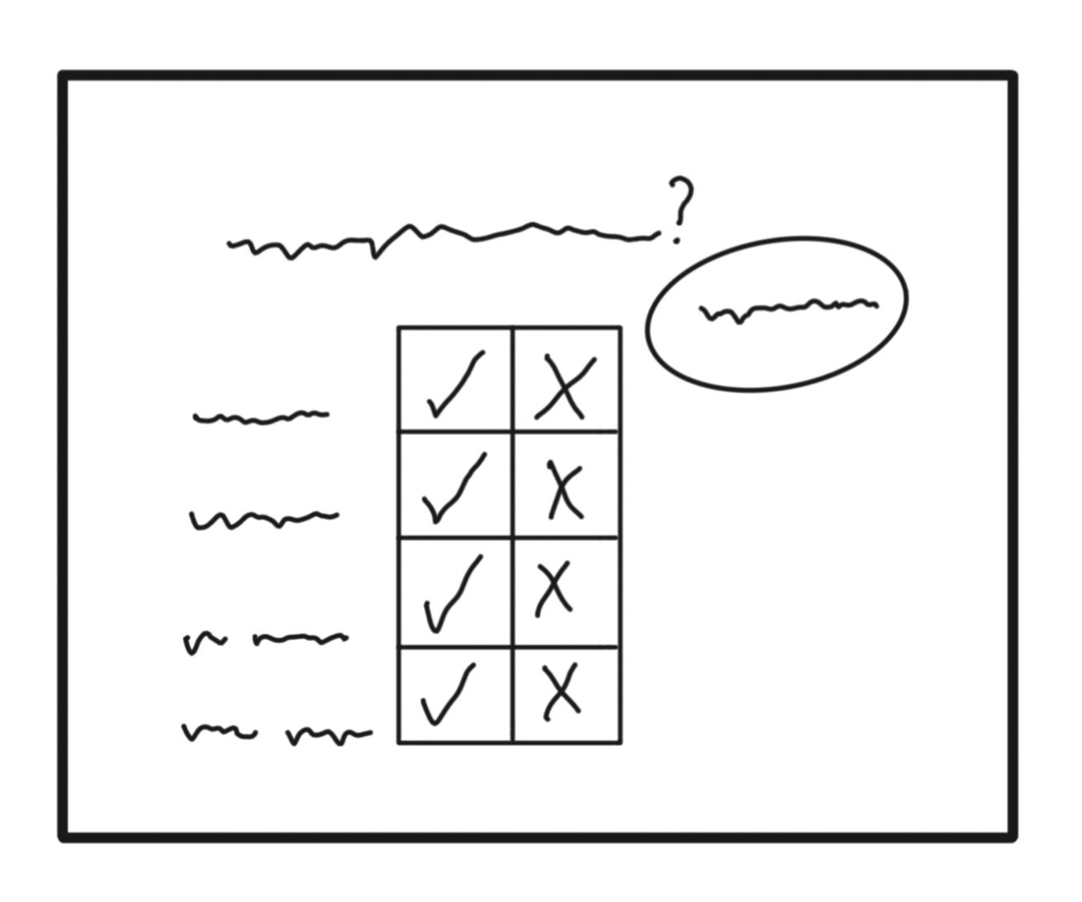

Figure 6: “grading”-screen for comparing the pre-defined correct answer to the answers which were given by the teams

## User stories

*All requirements are defined in point form and are rated either Mandatory (M) or Highly Desirable (HD) or Desirable (D), dependent on business need and University Policy.*

### Common Features

| **Requirement** | **Preference** |
| --- | --- |
| * 1. As a group leader, I want to see an overview of quiz rooms | HD |
| * 1. As a group leader, I want to join a quiz | M |
| * 1. As a group leader, I want to create a username. | HD |
| * 1. As a group leader, I want to submit answers to the questions | M |
| * 1. As a user, I want to be able to chat with my group | D |
| * 1. As a group leader, I want to be able to leave a quiz. | M |
| * 1. As a group leader, I want to see the results after a quiz | D |

### Admin Management

| **Requirement** | **Preference** |
| --- | --- |
| * 1. As an administrator, I want to log into the web application. | HD |
| * 1. As an administrator, I want to sign out from the web application. | HD |
| * 1. As an administrator, I want to see a custom Dashboard of quiz rooms | HD |
| * 1. As an administrator, I want to be able to delete quiz-rooms or questions. | HD |
| * 1. As an administrator, I want to be able to edit questions. | D |

### Account Management

| **Requirement** | **Preference** |
| --- | --- |
| * 1. As a user, I want to be able to create a quiz master account | M |
| * 1. As a quiz master, I want to log into the web application | M |
| * 1. As a quiz master, I want to sign out from the web application. | M |
| * 1. As a quiz master, I want to be able to delete my account | M |
| * 1. As a quiz master, I want to view my account settings | HD |
| * 1. As a quiz master, I want to change my password. | M |
| * 1. As a quiz master, I want to be able to change my profile picture. | HD |
| * 1. As a quiz master, I want to be able to change my contact information | M |
| * 1. As a user, I want to be able to change my profile picture. | D |

### Quiz Management

| **Requirement** | **Preference** |
| --- | --- |
| * 1. As a quiz master, I want to set a time limit | M |
| * 1. As a quiz master, I want to create new multiple/single-choice questions | M |
| * 1. As a quiz master, I want to create new free text questions | D |
| * 1. As a quiz master, I want to add pictures to questions | HD |
| * 1. As a quiz master, I want to review the free text answers after the quiz | HD |
| * 1. As a quiz master, I want to review the free text answers during the quiz | D |

1. Saladino Valeria et al, The Psychological and Social Impact of Covid-19: New Perspectives of Well-Being, Volume 11, 2020
2. [*https://kahoot.it/*](https://kahoot.it/)
3. [*https://virtualquiz.app/*](https://virtualquiz.app/)
4. [*https://ahaslides.com/*](https://ahaslides.com/)
5. [*http://www.quizduell-game.de*](http://www.quizduell-game.de)